**Lab Guide 6**

ConfigMap & Secret

Q.1 CREATE A YAML TO DEPLoy database with some env variable

MYSQL_ROOT_PASSWORD=redhat

MYSQL_DATABASE=mayank

MYSQL_USER=test1

MYSQL_PASSWORD =qwerty

Q.2 create a configmap with test1cm name and give 4 values as above

Q.3 create a secret with type generic and name of secret should be test1secret and give 4 values as above

Q.4 use test1cm configmap to create a pod using mysql image by yaml

Q.5 use test1secret secret to create a pod using mysql image by yaml

Ans: 1

oc run mydb --image mysql --env MYSQL_ROOT_PASSWORD=redhat --env MYSQL_DATABASE=mayank --env MYSQL_USER=test1 --env MYSQL_PASSWORD=qwerty --dry-run -o yaml > mydb.yaml

oc get pods

oc describe pod mydb

oc exec -it mydb – bash

mysql –uroot –p enter

redhat

show databases;

env

exit

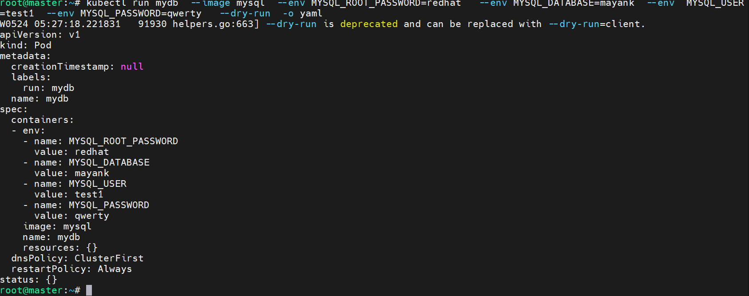

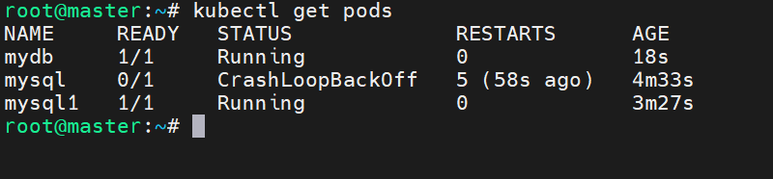

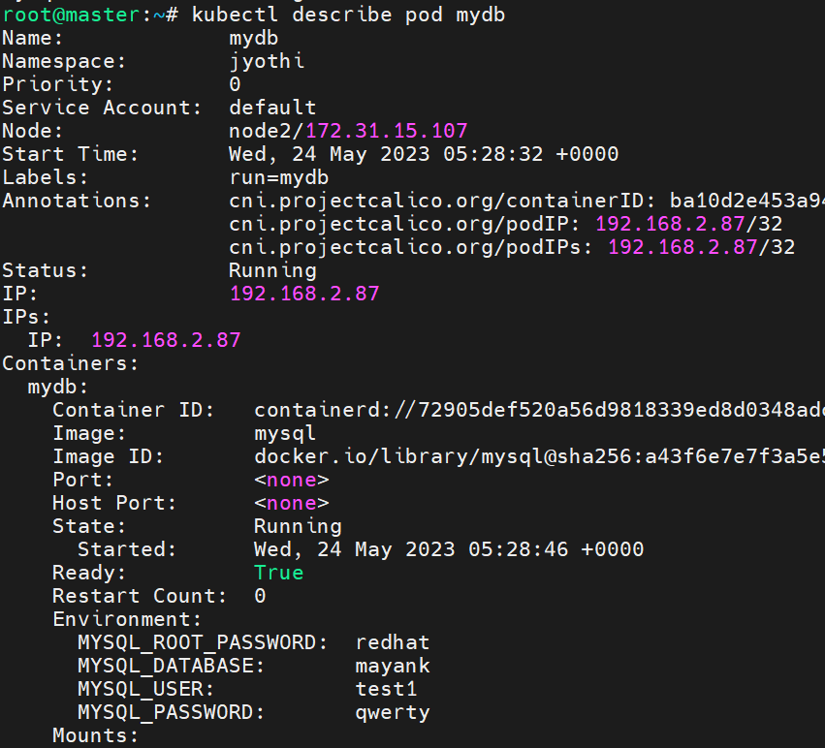

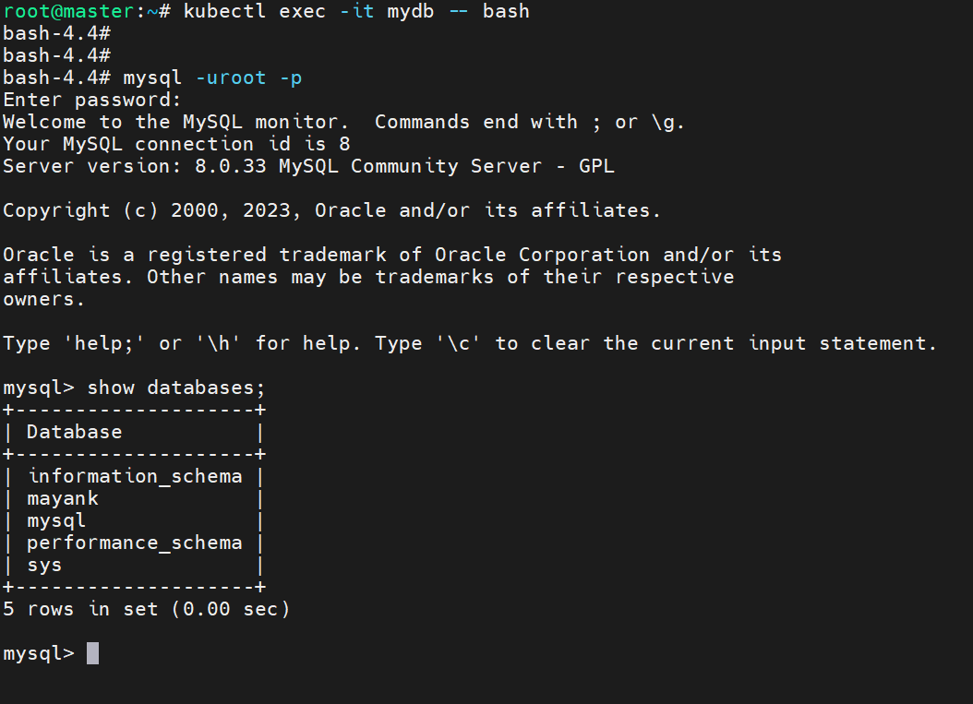

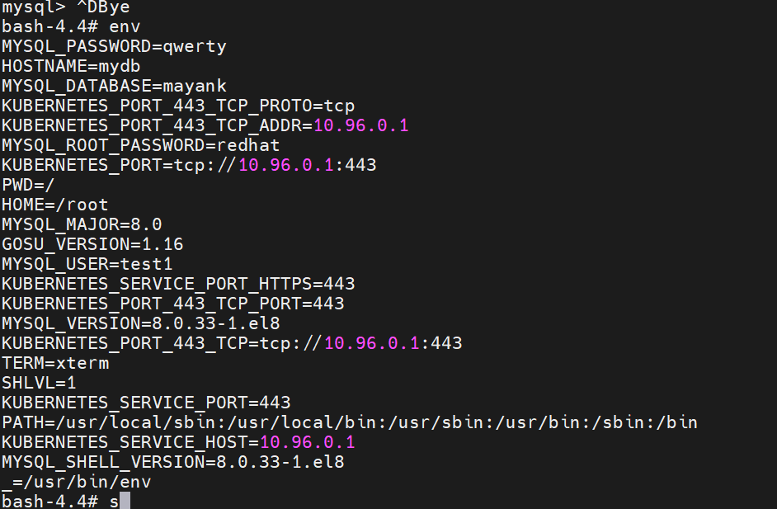

ANs: 2

vim mayankenv

cat mayankenv

oc create configmap test1cm --from-env-file mayankenv

oc get cm

oc describe cm test1cm

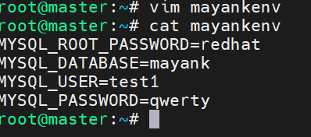

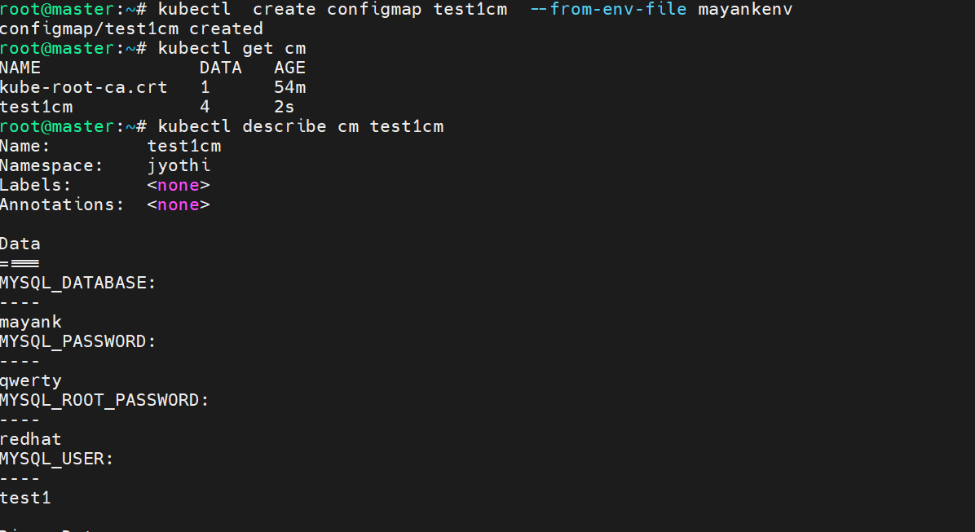

Ans: 3

oc create secret generic test1secret --from-env-file mayankenv

oc get secret

oc describe secret test1secret

oc edit secret test1secret

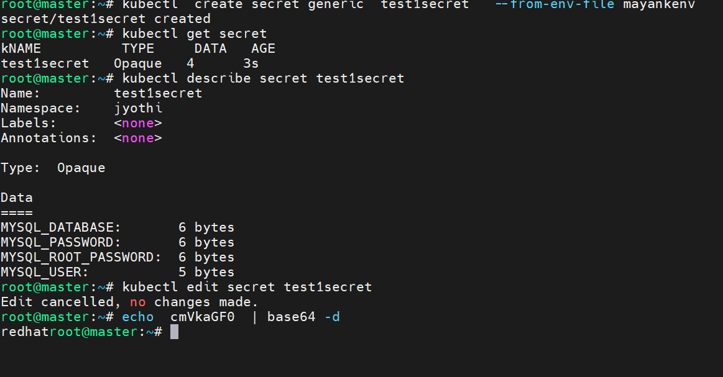

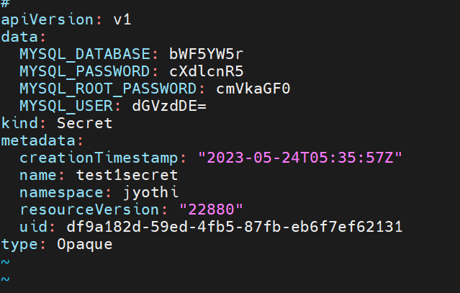

Ans: 4

vim cmmydb.yaml

cat cmmydb.yaml

oc create -f cmmydb.yaml

oc get pods

oc describe pod cmmydb

oc exec -it cmmydb -- env

oc exec -it cmmydb -- mysql -uroot -p

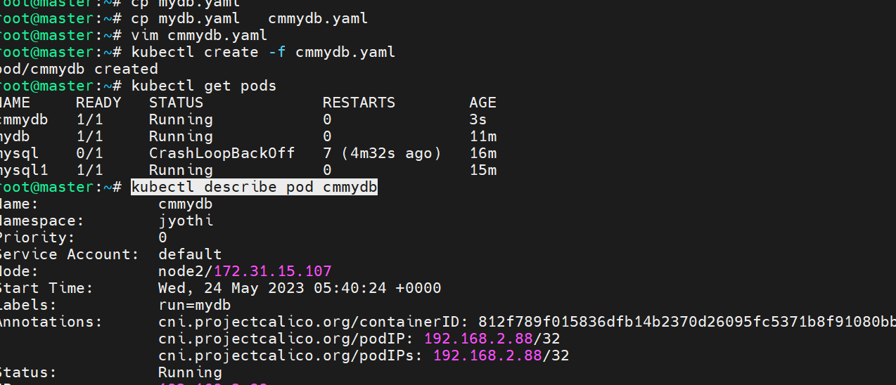

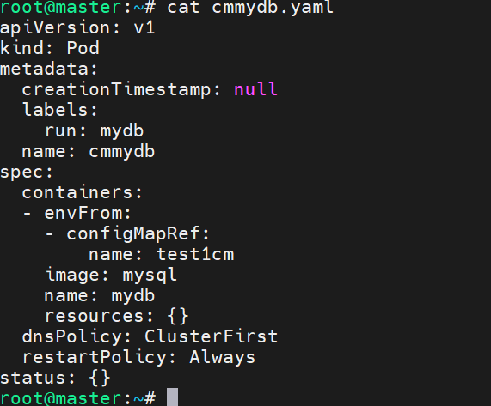

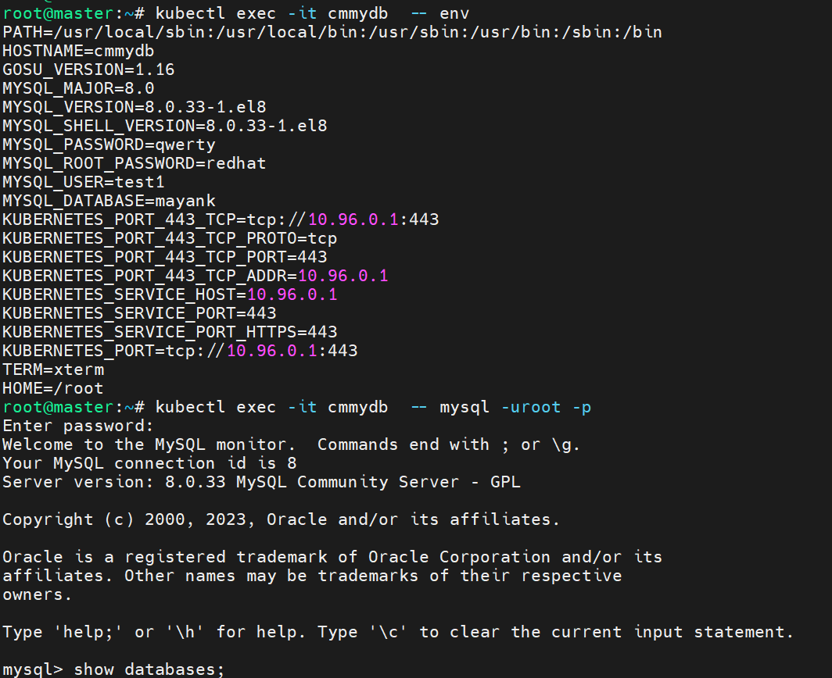

Ans: 5

vim secretmydb.yaml

cat secretmydb.yaml

oc create -f secretmydb.yaml

oc get pods

oc describe pod secretmydb

oc exec -it secretmydb – env

oc exec -it secretmydb -- mysql -uroot –p

